MACH4METAL

metalworking machinery
Transito 21, 6909 DA Babberich, Netherlands
Tel. + 31 (0)316 – 247123
Fax. + 31 (0)316 - 247956
info@mach4metal.com
www.mach4metal.com
Bank No : 66.52.13.883
IBAN : NL33 INGB 0665 2138 83
BIC : INGBNL2A
VAT : NL 815393635B01

DOOSAN PUMA240 mill turn

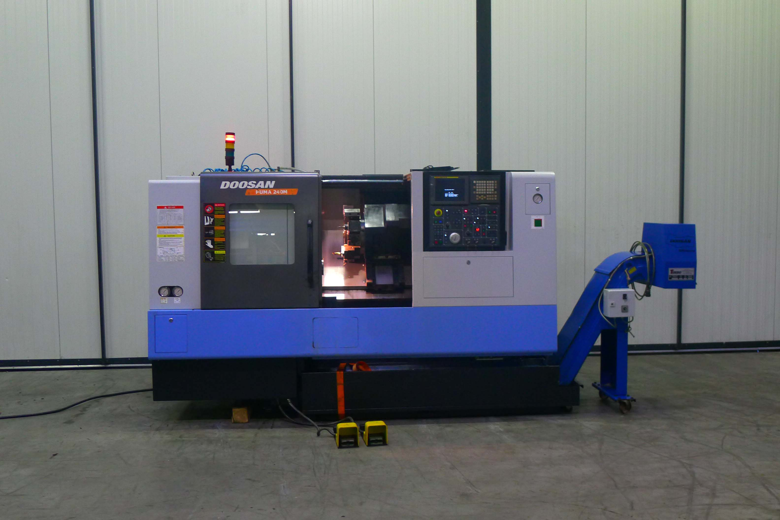
- Make : DOOSAN Infracore
- Typ : PUMA 240 MB
- Age : 2007
- Serial : P 24 M 3447

- Swing over slide : 550
- Swing over bed : 390
- DBC turning length : 513
- Spindle bore : 76
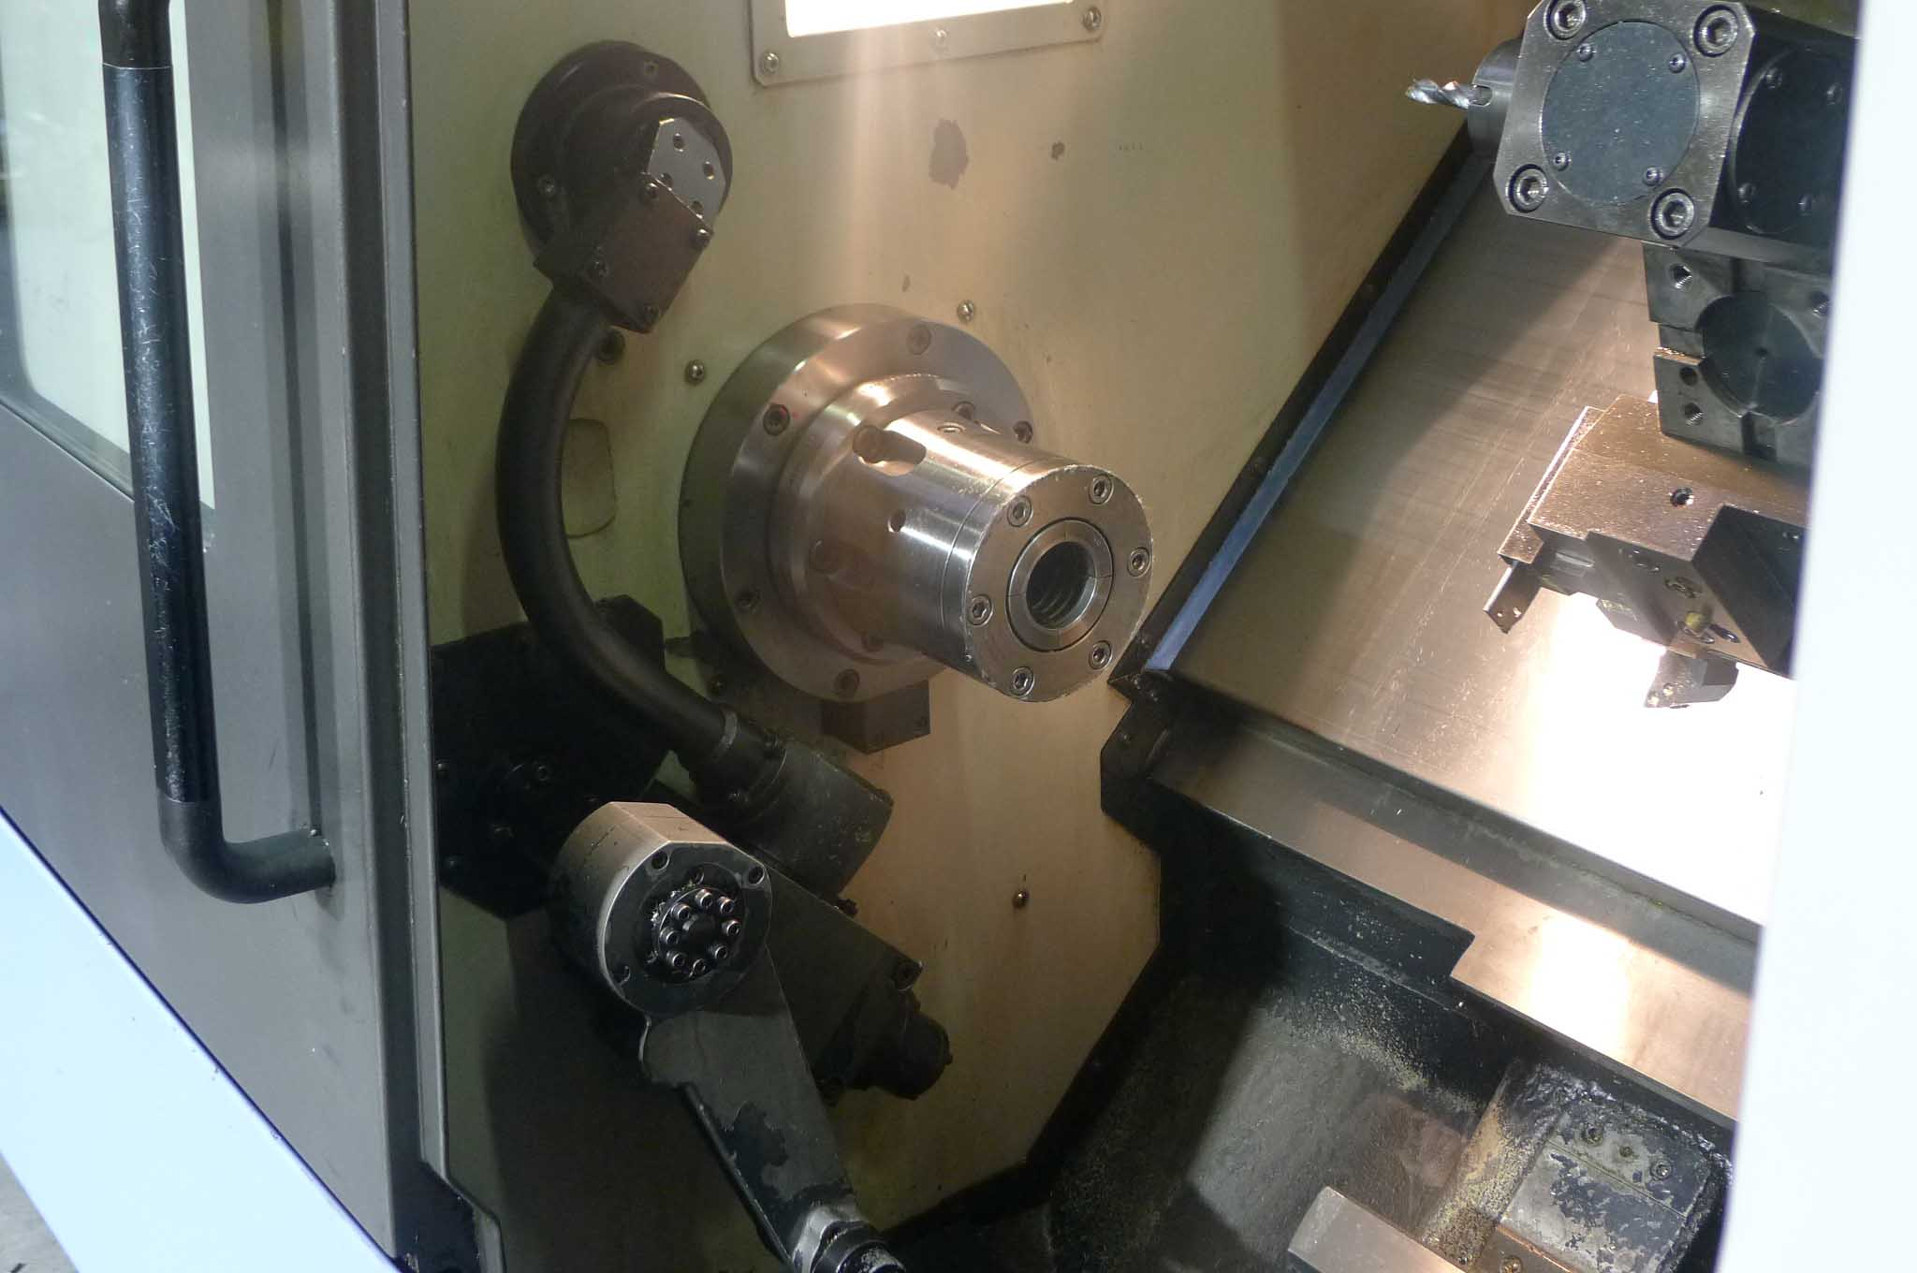
- Spindle speeds Rpm : 4.500
- Spindle main power Kw : 11
- Indexering : 360˚ (0.001)

- Travel X slide : 205
- Travel Z slide : 580
- Rapid feed X / Z Axis : 24 / 30 M/min

- Revolver 12 Positon ( BMT 55)
- Live tooling 5.5 kW / 5000 Rpm
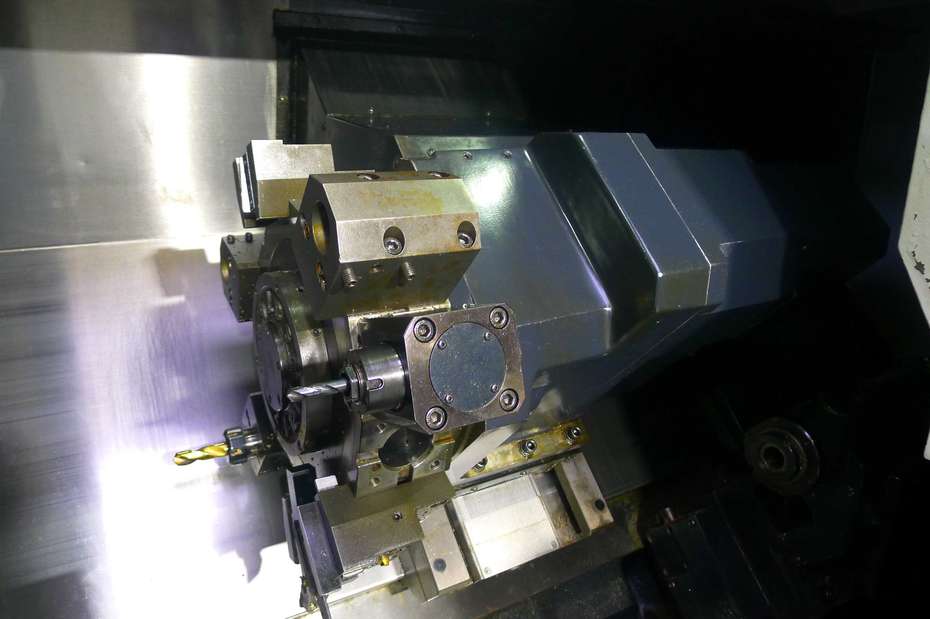

- Dimensions
- Length : 3.200
- Width : 1.900
- Height : 2.000
- Weight : 4.400 Kg

- CNC Control Fanuc 21 iTB + tool live manag
- Chip convenyor
- Coolant system 7 Bar
- Interface for bar feeder
- CNC programable tail stock
- Tool eye
- Tool gripper

Please Note: The above information has been obtained to the best of our ability and belief from, and from the manufacturers where possible. It is given in good faith, but its accuracy can not be guaranteed. Accordingly, it will not form a representation or constitute contractual terms. We advise you to check any vital details!

